

Stock Extraction Half Interface

Functional Design Document

Document History

|  |  |  |  |
| --- | --- | --- | --- |
| **Version** | **Updated by** | **Date** | **Comments** |
| 1.0 | FLAVIEN RECOUVREUR | 20/02/2015 | DRAFT |
|  |  |  |  |
|  |  |  |  |
|  |  |  |  |
|  |  |  |  |
|  |  |  |  |
|  |  |  |  |

Document Sign-off

|  |  |  |  |
| --- | --- | --- | --- |
| **Name** | **Role** | **Date** | **Signature** |
| **Pascal ESPINOUSE** |  |  |  |
| **Aliasgar Muchhala** |  |  |  |
| **Gyaneshwar Dubey** |  |  |  |
|  |  |  |  |
|  |  |  |  |
|  |  |  |  |
|  |  |  |  |

Document references

|  |  |  |  |
| --- | --- | --- | --- |
| **Reference and Document Title** | | **Version Number** | **Date** |
|  |  |  |  |

# Table of Contents

Table of Contents 2

1. Introduction 4

1.1 Document Purpose 4

1.2 Intended Audience 4

1.3 Document Scope 4

1.4 Document Structure 4

1.5 Additional Resources 4

1.6 Interface List 5

Brief description of the extraction half interface 6

2.1 Extraction half interface description 6

2.2 Extraction half interface connectivity overview 6

2.3 Extraction half Interface behavior 6

2.4 Message format and specification 6

2.5 Data 7

2.6 ER Diagram 7

2.7 File / Message processing 11

2.8 Transformations 11

2.9 Exception Management and Logging 11

2.9.1 Exception Management 11

2.9.2 Logging / Audit 12

2.10 Security requirements 12

1. Introduction
   1. Document Purpose

This document is the Functional Design Document which provides information of Stock Extraction half interface. It covers:  
a) Brief description of the half interface  
b) Message format and specification  
c) Security Requirement

* 1. Intended Audience

This document is aimed at the client who wants to discover the principle of the hotfolder addon in Hybris.

* 1. Document Scope

This document covers the details about the functionality hot folder addon.

* 1. Document Structure

|  |  |  |
| --- | --- | --- |
| Section | | Description |
| 1 | Introduction | Describes the purpose and intended audience of the document and explains its structure. |
| 2 | Brief Description | Overview of the module. |
| 3 | Appendices | Supporting information |

* 1. Additional Resources

|  |  |  |  |
| --- | --- | --- | --- |
| # | Description | URL | Purpose |
| 1 | Wiki Portal | <https://wiki.hybris.com> | To gather more information |
| 2 | Coconet | <https://coconet2.capgemini.com/sf/go/doc3313610?nav=1> | To refer technical specifications |
| 3 | Data importation | <https://wiki.hybris.com/display/accdoc/Data+Importing+Capability+in+the+Commerce+Accelerator> | Documentation of import process |

* 1. Interface List

|  |  |  |  |
| --- | --- | --- | --- |
| 1 | File stockLevelsData with header |  | Template of header stockLevelsData |
| 2 | File stockLevelsData with data |  | Template of stockLevels with data |

Brief description of the extraction half interface

* 1. Extraction half interface description

The hotfolder module has been created to permit the importation of CSV files easily. The files have just to be copy in the stocklevels folder to be digested by the interface. The process converts the file in IMPEX format specific to Hybris and then imports these data in the database. If the file is successfully imported, he is next moved in archive folder. Otherwise he is moved in error folder and you have to analyze the file in log folder of interfaceerror folder to understand the error.

* 1. Extraction half interface connectivity overview

N.A

* 1. Extraction half Interface behavior

The poller refreshes the directory at a given frequencies (default: 1000 ms).   
If a match file is present in the directory import process with parameters starts automatically (conversion into IMPEX format,importation,clean).  
The interfaceerror module formalizes the errors messages to make them understandable by the user.

* 1. Message format and specification

The data about stockLevels have to be saved in CSV files. The name of the file MUST follow this mask:

* StockLevelsData-xxx.csv where “xxx” is the version of the file. E.G StockLevelsData-001.csv

StockLevelsData is the file that correspond to the details informations about stock. The file must follow this structure:

The files must be placed in the folder: hybris/data/acceleratorservices/import/master/stocklevels

* 1. Data

Here is an example of data for stockLevelsData file: 

* 1. ER Diagram

**When you find example with (code), you have to import the object relation before the stockLevels data.**

**Stocklevels ER Diagram:**

|  |  |  |  |  |  |
| --- | --- | --- | --- | --- | --- |
| **Name** | **Description** | **Type** | **Default Value** | **Mandatory** | **Example** |
| productCode | Id of the product | Integer | / | TRUE | 137220 |
| available | Availability of the product | Integer | / | TRUE | 11 |
| inStockStatus | Stock status of the product | StockStatus | / | FALSE | forceOutOfStock(code) |
| maxPreOrder | Maximum preorderable items for the product | Integer | 1 | TRUE | 1 |
| maxStockLevelHistoryCount | Indicates how many histories should be saved related to the updates | Integer | -1 | TRUE | 0 |
| nextDeliveryTime | Next delivery time | Date | / | FALSE | 15/05/2015 08:30 |
| overSelling | Overselling of the product | Integer | 0 | TRUE | 5 |
| preOrder | Preorderable items for the product | Integer | / | TRUE | 0 |
| releaseDate | Release date | Date | / | FALSE | 15/05/2015 08:30 |
| reserved | Status of the reservation | Integer | 0 | TRUE | 0 |
| warehouse | Name of the warehouse | WareHouse | default | TRUE | warehouse_e(code) |
| treatNegativeAsZero | Value automatically set to 0 if negative | Boolean | / | TRUE | 1 |

* 1. File / Message processing

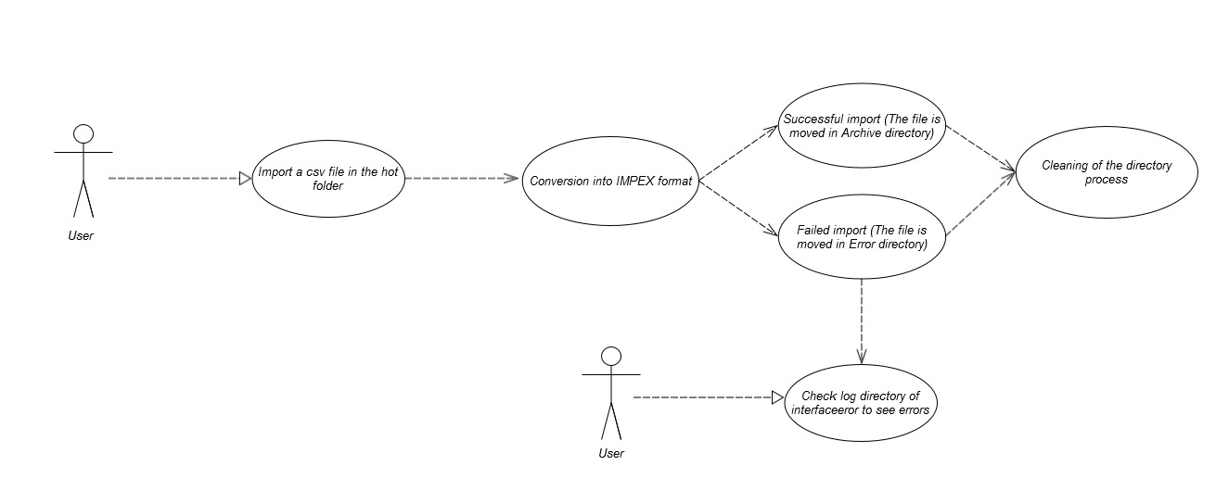

Description: User import a csv file then check log directory if the process failed

Location of the folder to drag and drop the files: hybris/data/acceleratorservices/import/master/stocklevels

The hybris serveur must be launch before the importation

* 1. Transformations

The csv file is converted in an impex file. The impex is then used to import data.  
The name and the order of the CSV column and the impex column are the same.

* 1. Exception Management and Logging
     1. Exception Management

|  |  |
| --- | --- |
| **Exception** | **Message** |
| UnresolvedValueException | Exception caught when :   * error finding existing item * no existing item found for update * cannot create due to unresolved mandatory/initial columns |
| InsufficientDataException | Exception caught when :   * target type is not permitted by current header – {header} * cannot import localized column without default session language |
| ImpexException | Exception caught when :   * unknow mode (INSERT | UPDATE | INSERT_UPDATE | REMOVE) * batch inserts are not supported – found more than one item for value line {valueLine} * Configured type {type} is abstract and you want to insert {valueLine}. Please specify the subtype of the item you want to create at the first column of the value line or change the configured type * Composed type {code} of found item with PK {PK} is not an instance of specified type {typecode} * Composed type {code} of found item with PK {PK} is not permitted in Insert_Update mode, because of {typeErrorMsg} |
| HeaderValidationException | Exception caught when :   * cacheUnique modifier is not allowed for Singleton types, please remove cacheUnique modifier |

* + 1. Logging / Audit

N.A

* 1. Security requirements

User must have a sftp access to the server in order to drag and drop the csv file into the hotfolder.